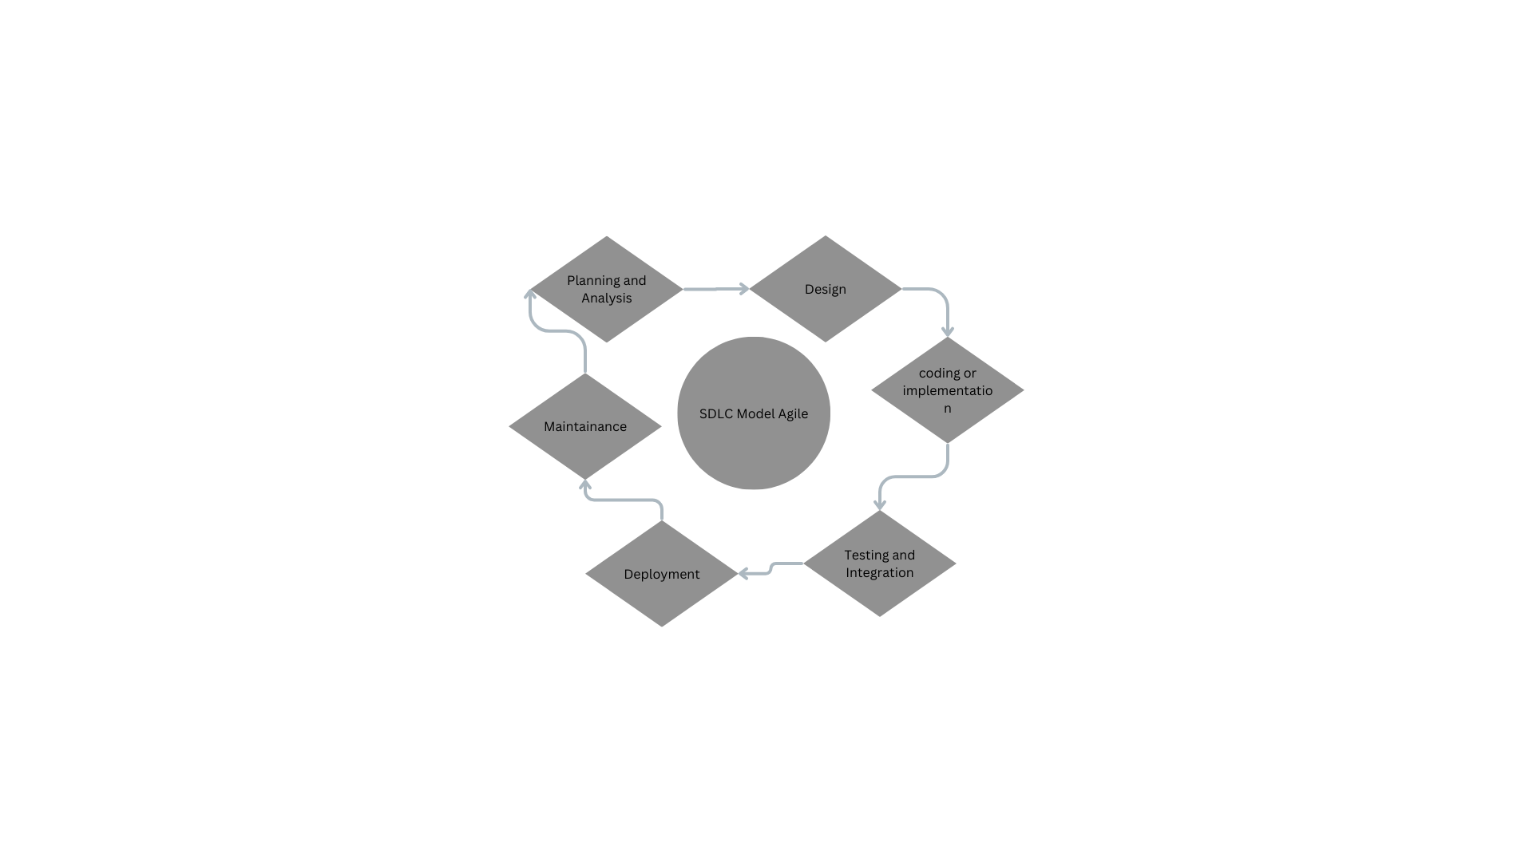 **SDLC Model Overview**

The Software Development Life Cycle (SDLC) is a structured process for planning, designing, developing, testing, and deploying high-quality software applications. Each phase of the SDLC is crucial and interconnected, ensuring a smooth and successful software development process.

**Planning and Analysis**

* This phase involves understanding the needs of the stakeholders (users, clients, etc.) and defining the functionalities of the software.
* A clear understanding of requirements ensures the software is built to address the intended purpose and meets user expectations.

**Design**

* In this phase, a blueprint for the software is created based on the gathered requirements. This includes system architecture, user interface (UI) design, and data flow.
* A well-defined design ensures the software is built on a solid foundation, is easy to use, and can be efficiently developed.

**Coding or Implementation**

* This phase involves coding the software based on the design specifications. Developers write code, integrate different components, and create a functional software application.
* Implementation brings the design to life, transforming requirements into a working software program.

**Testing and Integration**

* The software is thoroughly tested in this phase to identify and fix bugs and ensure it meets the requirements. Different testing levels are conducted, such as unit testing, integration testing, and system testing.
* Testing is essential to deliver high-quality software that functions as intended and is free of errors.

**Deployment**

* In this final phase, the tested software is released to the end-users. This may involve deploying the software on-premises, in the cloud, or on mobile devices.
* Deployment makes the software available to users, allowing them to benefit from its functionalities.

**Maintenance**

* After the deployment is done the maintainence is carried out for the project in order to bring the next phase of project forward by clearing or fixing any residual from the previous one.